7 marks questions

Unit 1:

Explain briefly about Information security and its elements.

To help protect your identity, it’s important to take steps to help protect yourself and your personal information. These steps can include:
- Use strong, secure passwords. Use a complex and unique password for each of your online accounts.
- Monitor your bank and other financial accounts. Check your accounts on a regular basis for unfamiliar activity. And if the companies offer activity alerts via text or email, it may make sense for you to sign up for them.
- Check your credit report. Do so regularly to see if a thief has attempted to open a new credit card or another account in your name.
- Take action as soon as possible. If you see suspicious activity, contact the financial institution involved immediately. If your information was stolen in a data breach, let them know that, as well.
- Secure your phone. If your phone doesn’t have a password, give it one. Although entering a password every time you use your phone is tedious, it provides a line of defense if your device is lost or stolen. Think about all the information a criminal could access with your unprotected phone.
- Use only secure URLs. Reputable sites begin with https://. The “s” is key. This is especially important when entering credit card or other personal information.
- Implement high-quality security software. Install and use a software suite that includes malware and virus protection — and always keep it updated.
- Back up your files and ensure their safety. Use secure online Data Backup solutions as backup for your PC in addition to its other security features.
- Wipe your hard drive. If you are recycling your old computer, make sure that you clear your hard drive prior to disposal. The same goes for your smartphones and tablets.
- Avoid oversharing on social media. Never post anything pertaining to sensitive information and adjust your settings to make your profiles private. While you’re at it, hold off sharing vacation pics on social media while you’re still on vacation. That tells everyone your house may be sitting empty, a perfect target for burglary.
- Use an identity theft protection or credit monitoring service. The mess caused by a stolen identity could take months or even years to fix. Given the recent number of data breaches, it’s important to consider identity theft protection or a credit monitoring service.

3.What is Social Engineering and explain the Impact of Social Engineering Attack on an Organization.
Social engineering is the psychological manipulation of people into performing actions or divulging confidential information. Social engineering is a technique scammers use to manipulate people, for instance, employees at a company, to reveal sensitive and private information to them.

The Impact of Social Engineering Attack on an Organization.

- Financial losses as a result of social engineering attacks
This is perhaps the one consequence of hacker attacks that everyone knows about – the amount of money the company loses directly as a result of a social engineering attack.

Loss of productivity as a result of a social engineering cyber attack
Any successful cyber attack causes a huge disruption of normal business operations. The IT team and several management-level employees need to postpone their other tasks in order to deal with the breach, all employees need to be updated about the hack and trained to prevent the same attack in the future, etc. All of this takes away time from the employee’s duties and significantly lowers productivity.

The cost of recovering after a social engineering attack
Another common cost associated with spear-phishing attacks is the recovery cost, which represents the amount of money needed to hire an incident response team, purchase software that will prevent the same attack from occurring in the future and resolve the issue with the customers if their data was stolen during the attack.

Cyber-attacks cause business disruption
This consequence of social engineering is similar to the loss of productivity but it measures the impact of the hack on your customer satisfaction rates and your supply chain. Since a successful hacker attack disrupts your normal business operations, your business may experience downtime in product manufacturing, shipping or other operations

Social engineering hacks cause huge damage to your reputation
If you were a customer or a supplier of a company that experienced a significant cyber security breach, how likely would you be to trust this company again? Would you continue to do business with this company? Unfortunately, for many businesses and, the answer is ‘no’ – people don’t want to put themselves and their information in danger so a lot of businesses lose a significant number of customers and suppliers after a security breach.

5. Define the term Malware and what are the different ways for malware to Enter a system.
“Malware” is short for “malicious software” - computer programs designed to infiltrate and damage computers without the user’s consent. “Malware” is the general term covering all the different types of threats to your computer safety such as viruses, spyware, worms, trojans, rootkits and so on. Today many experts believe the amount of malicious software being released on the web might actually surpass the release of valid software.

Different types of malware

The term malware includes viruses, worms, Trojan Horses, rootkits, spyware, keyloggers and more. To get an overview of the difference between all these types of threats and the way they work, it makes sense to divide them into groups:

Viruses and worms – the contagious threat

Viruses and worms are defined by their behavior – malicious software designed to spread without the user’s knowledge. A virus infects legitimate software and when this software is used by the computer owner it spreads the virus – so viruses need you to act before they can spread. Computer worms, on the other hand, spread without user action. Both viruses and worms can carry a so-called “payload” – malicious code designed to do damage.

Trojans and Rootkits – the masked threat
Trojans and rootkits are grouped together as they both seek to conceal attacks on computers. Trojan Horses are malignant pieces of software pretending to be benign applications. Users therefore download them thinking they will get a useful piece of software and instead end up with a malware infected computer. Rootkits are different. They are a masking technique for malware, but do not contain damaging software. Rootkit techniques were invented by virus writers to conceal malware, so it could go unnoticed by antivirus detection and removal programs. Today, antivirus products, like BullGuard Internet Security, strike back as they come with effective rootkit removal tools.

Spyware and keyloggers – the financial threat

Spyware and keyloggers are malware used in malicious attacks like identity theft, phishing and social engineering - threats designed to steal money from unknowing computer users, businesses and banks.

Malware Analysis refers to the process by which the purpose and functionality of the given malware samples are analyzed and determined. The culled-out information provides insights into developing an effective detection technique for the malicious codes. Additionally, it is an essential aspect for developing the efficient removal tools which can definitely perform malware removal on an infected system.

7.What is meant by zero day attack? Zero Day Attack

If a hacker manages to exploit the vulnerability before software developers can find a fix, that exploit becomes known as a zero day attack.
Zero day vulnerabilities can take almost any form, because they can manifest as any type of broader software vulnerability. For example, they could take the form of missing data encryption, SQL injection, buffer overflows, missing authorizations, broken algorithms, URL redirects, bugs, or problems with password security.
This makes zero day vulnerabilities difficult to proactively find—which in some ways is good news, because it also means hackers will have a hard time finding them. But it also means it’s difficult to guard against these vulnerabilities effectively.

How to Protect Against Zero Day Attacks?

It’s difficult to protect yourself from the possibility of a zero day attack, since they can take many forms. Almost any type of security vulnerability could be exploited as a zero day if a patch is not produced in time. Additionally, many software developers intentionally try not to publicly reveal the vulnerability, the hopes that they can issue a patch before any hackers discover that the vulnerability is present.
There are a few strategies that can help you defend your business against zero day attacks:

Stay informed
Zero day exploits aren’t always publicized, but occasionally, you’ll hear about a vulnerability that could potentially be exploited. If you stay tuned to the news and you pay attention to releases from your software vendors, you may have time to put in security measures or respond to a threat before it gets exploited.

Keep your systems updated
Developers work constantly to keep their software updated and patched to prevent the possibility of exploitation. When a vulnerability is discovered, it’s only a matter of time before they issue a patch. However, it’s up to you and your team to make sure your software platforms are up to date at all times. The best approach here is to enable automatic updates, so your software is updated routinely, and without the need for manual intervention.

Employ additional security measures
Ensure that you are using security solutions that protect against zero day attack because these security measures may not be enough to fully protect you from a zero day attack

8.What is data breach?
A data breach is a security incident in which information is accessed without authorization. Data breaches can jeopardize businesses and consumers in a variety of ways. They are a costly expense that can damage lives and reputations and take time to repair.

It may seem like stories of massive data breaches pop up in the news frequently these days. But it shouldn’t be all that surprising.

As technology progresses, more and more of our information has been moving to the digital world. As a result, cyber attacks have become increasingly common and costly.

Globally, the average total cost to a company of a data breach is $3.86 million, according to a study by the Ponemon Institute. This means that at $148 on average per stolen record, online crime is a real threat to anyone on the internet.

Corporations and businesses are extremely attractive targets to cybercriminals, simply due to the large amount of data that can be grabbed in one single action.

Why do data breaches occur?

Cybercrime is a profitable industry for attackers and continues to grow. Hackers seek personally identifiable information to steal money, compromise identities, or sell over the dark web. Data breaches can occur for a number of reasons, including accidentally, but targeted attacks are typically carried out in these four ways:

- Exploiting system vulnerabilities. Out-of-date software can create a hole that allows an attacker to sneak malware onto a computer and steal data.
- Weak passwords. Weak and insecure user passwords are easier for hackers to guess, especially if a password contains whole words or phrases. That’s why experts advise against simple passwords, and in favor of unique, complex passwords.
- Drive-by downloads. You could unintentionally download a virus or malware by simply visiting a compromised web page. A drive-by download will typically take advantage of a browser, application, or operating system that is out of date or has a security flaw.
- Targeted malware attacks. Attackers use spam and phishing email tactics to try to trick the user into revealing user credentials, downloading malware attachments, or directing users to vulnerable websites. Email is a common way for malware to end up on your computer. Avoid opening any links or attachments in an email from an unfamiliar source. Doing so can infect your computer with malware. And keep in mind that an email can be made to look like it comes from a trusted source, even when it’s not.
Unit 2:

- What is Footprinting and types of Footprinting? Explain Footprinting through Social Networking Sites using sherlock.
Footprinting is the technique to collect as much information as possible about the targeted network/victim/system. It helps hackers in various ways to intrude on an organization's system. This technique also determines the security postures of the target. Footprinting can be active as well as passive.
Passive footprinting/pseudonymous footprinting involves collecting data without the owner, knowing that hackers gather his/her data.
In contrast, active footprints are created when personal data gets released consciously and intentionally or by the owner's direct contact.

Sherlock methods:

Footprinting through Search Engines
This is a passive information gathering process where we gather information about the target
from social media, search engines, various websites etc. Information gathered includes name, personal details, geographical location detrails, login pages, intranet portals etc. Even some target specific information like Operating system details, IP details, Netblock information, technologies behind web application etc can be gathered by searching through search engines

Eg: collecting information from Google, Bingo etc

Email Footprinting

email header reveals information about the mail server, original sender’s email id, internal IP addressing scheme, as well as the possible architecture of the target network

Google Hacking/Google Dorks

This is a process of creating search queries to extract hidden information by using Google operators to search specific strings of text inside the search results.

Some google operators, site, allinurl, inurl, allintitle

DNS Footprinting

DNS is a naming system for computers that converts human-readable domain names into computer readable IP-addresses and vice versa. DNS uses UDP port 53 to serve its requests. A zone subsequently stores all information, or resource records, associated with a particular domain
into a zone file; Resource records responded by the name servers should have the following fields:

- Domain Name — Identifying the domain name or owner of the records
- Record Types — Specifying the type of data in the resource record
- Record Class — Identifying a class of network or protocol family in use
- Time to Live (TTL) — Specifying the amount of time a record can be stored in cache before discarded.
- Record Data — Providing the type and class dependent data to describe the resources.

Footprinting through Social Engineering:

  - Social media like twitter, Facebook are searched to collect information like personal details, user credentials, other sensitive information using various social engineering techniques. Some of the techniques include
  - Eavesdropping: It is the process of intercepting unauthorized communication to gather information
  - Shoulder surfing: Secretly observing the target to gather sensitive information like passwords, personal identification information, account information etc

6.Explain about Horizontal and Vertical Privilege Escalation.

  - Vertical Privilege Escalation
Vertical privilege escalation occurs when an attacker gains access directly to an account with the intent to perform actions as that person. This type of attack is easier to pull off since there is no desire to elevate permissions. The goal here is to access an account to further spread an attack or access data the user has permissions to.
Day in and day out I analyze numerous phishing emails that attempt to perform this attack. Whether it’s a “bank”, “Amazon”, or any other countless number of ecommerce sites, the attack is the same. “Your account will be deactivated due to inactivity. Please click this link and login to keep your account active.” This is, however, one example of many cookie-cutter phishing
templates seen in “the wild”.

Horizontal Privilege Escalation
Horizontal privilege escalation is a bit tricky to pull off as it requires the attacker to gain access to the account credentials as well as elevating the permissions. This type of attack tends to require a deep understanding of the vulnerabilities that affect certain operating systems or the use of hacking tools.
Phishing campaigns have been used to perform the first part of the attack to gain access to the account. When it comes to elevating permissions, the attacker has a few options to choose from. One option is to exploit vulnerabilities in the operating system to gain system or root-level access. The next option would be to use hacking tools, like Metasploit, to make the job a bit easier.

How to Defend against privilege Escalation?

    - Fully manage the identity lifecycle, including provisioning and de-provisioning of identities and accounts to ensure there are no orphaned accounts that could be hijacked.
    - Use a password management solution to consistently apply strong credential management practices (discovery, vaulting, central management, check-in, check-out) for both human and machines. This also entails eliminating default and hardcoded credential.
    - Enforce least privilege: Remove admin rights from users and reduce application and machine privileges to the minimum required. Just-in-time access should also be implemented to reduce persistent or standing privileges.
    - Apply advanced application control and protection to enforce granular control over all application access, communications, and privilege elevation attempts.
    - Monitor and manage all privileged sessions to detect and quickly address any suspicious activity that might indicate a hijacked account or an illicit attempt at privilege escalation or lateral movement.
    - Harden systems and applications: This complements the principle of least privilege and can involve configuration changes, removing unnecessary rights and access, closing ports, and more. This improves system and application security and helps prevent and mitigate the potential for bugs that leave vulnerability to injection of malicious code (i.e. SQL injections), buffer overflows, etc. or other backdoors that could allow privilege escalation.
    - Vulnerability management: Continuously identify and address vulnerabilities, such as with patching, fixing misconfigurations, eliminating default and/or embedded credentials, etc.
    - Secure remote access should always be monitored and managed for any form of privileged access since attacks can occur horizontally and vertically to exploit privileges.

8.Explain about different techniques followed by an attacker to cover his/her tracks on the target system.

Clearing Tracks
  - Covering tracks refers to the activities carried out by an attacker to hide malicious acts
  - The attacker’s intentions include: continuing access to the victim’s system, remaining unnoticed and uncaught, deleting evidence that might lead to his prosecution
  - The attacker overwrites the server, system, and application logs to avoid suspicious

Unit 3:

- What is Vulnerability Assessment? Explain the types of Vulnerability Assessment with diagram?

Vulnerability Assessment

Vulnerability Assessment can be defined as a process of examination, discovery, and identification of system and applications security measures and weaknesses. Systems and applications are examined for security measures to identify the effectiveness of deployed security layer to withstand attacks and misuses. Vulnerability assessment also helps to recognize the vulnerabilities that could be exploited, need of additional security layers, and information's that can be revealed using scanners.

Types of Vulnerability Assessments

- Active Assessments: Active Assessment is the process of Vulnerability Assessment which includes actively sending requests to the live network and examining the responses. In short, it is the process of assessment which requires probing the target host.
- Passive Assessments: Passive Assessment is the process of Vulnerability Assessment which usually includes packet sniffing to discover vulnerabilities, running services, open ports and other information. However, it is the process of assessment without interfering the target host.
- External Assessment: Another type in which Vulnerability assessment can be categorized is an External assessment. It the process of assessment with hacking's perspective to find out vulnerabilities to exploit them from outside.
- Internal Assessment: This is another technique to find vulnerabilities. Internal assessment includes discovering vulnerabilities by scanning internal network and infrastructure.

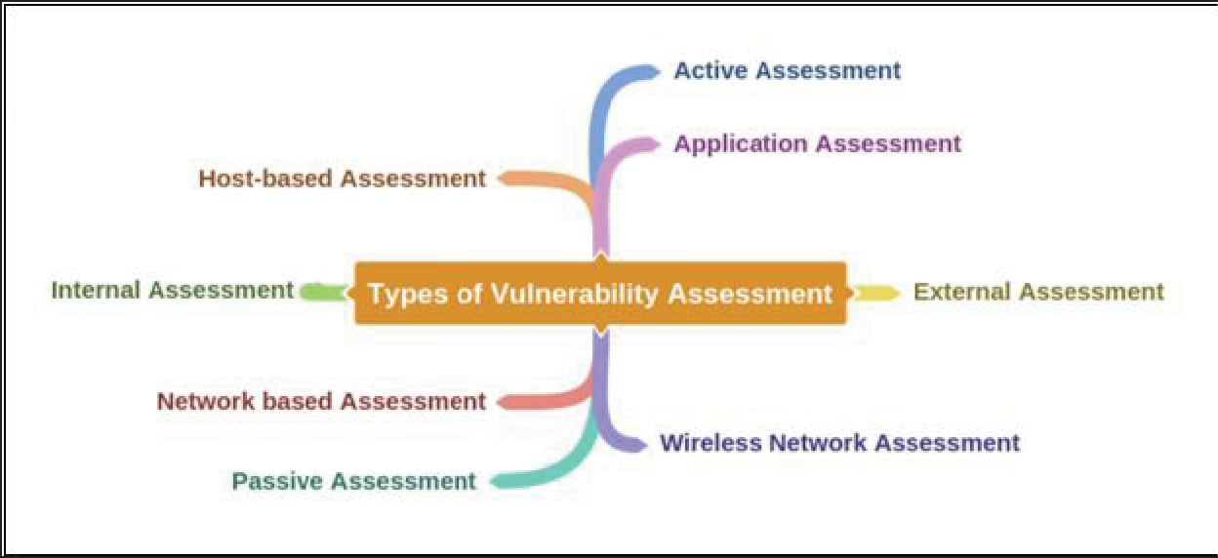

3 Explain CVSS and CVE? Name any 4 Vulnerability scanning tools.
Common Vulnerability Scoring Systems (CVSS)
The Common Vulnerability Scoring System (CVSS) provides a way to capture the principal characteristics of vulnerability and produce a numerical score reflecting its severity. The numerical score can then be translated into a qualitative representation (such as low, medium, high, and critical) to help organizations properly assess and prioritize their vulnerability management processes.

Security | Base Score Rating
None | 0.0
Low | 0.1 - 3.9
Medium | 4.0 - 6.9
High | 7.0 - 8.9
Critical | 9.0 - 10.0

To learn more about CVSS-SIG, go to website https://www.first.org.

Common Vulnerabilities and Exposure (CVE)
Common Vulnerabilities and Exposure (CVE) is another platform where you can find the information about vulnerabilities. CVE maintain the list of known vulnerabilities including an identification number and description of known cybersecurity vulnerabilities.
U.S. National Vulnerability Database (NVD) was launched by National Institute of Standards and Technology (NIST), The CVE List feeds NVD, which then builds upon the information included in CVE Entries to provide enhanced information for each entry such as fix information, severity scores, and impact ratings. As part of its enhanced information, NVD also provides advanced searching features such as by OS; by vendor name, product name, and/or version number; and by vulnerability type, severity, related exploit range and impact.
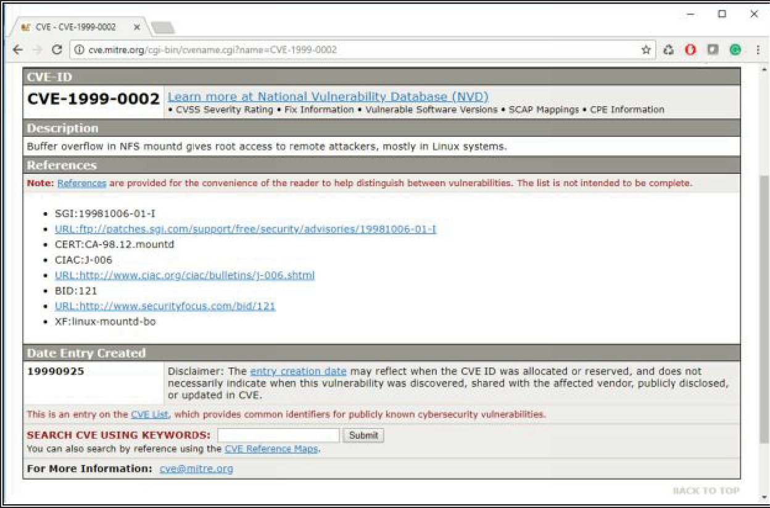

Figure3:CommonVulnerabilityandExposures(CVE)

Vulnerability Scanning

In this era of modern technology and advancement, finding vulnerabilities in an existing environment is becoming easy using different tools. Various tools, automated as well as manual tools, are available to help you in finding vulnerabilities. Vulnerability Scanners are automated utilities which are specially developed to detect vulnerabilities, weakness, problems, and holes in an operating system, network, software, and applications. These scanning tools perform deep inspection of scripts, open ports, banners, running services, configuration errors, and other areas.

These vulnerability scanning tools include: -
- Nessus
- OpenVAS
- Retina
- Nexpose
- GFI LanGuard
- Qualys FreeScan

4 Explain any 3 popular penetration testing tools.

Popular penetration testing tools

- The Metasploit Project is an open source project owned by the security company Rapid7, which licenses full-featured versions of the Metasploit software. It collects popular penetration testing tools that can be used on servers, online-based applications and networks. Metasploit can be used to uncover security issues, to verify vulnerability mitigations and to manage security processes.
- Nmap, short for "network mapper," is a port scanner that scans systems and networks for vulnerabilities linked to open ports. Nmap is directed to the IP address or addresses on which the system or network to be scanned is located and then tests those systems for open ports; in addition, Nmap can be used to monitor host or service uptime and map network attack surfaces.
- Wireshark is a tool for profiling network traffic and for analyzing network packets. Wireshark enables organizations to see the smaller details of the network activities taking place in their networks. This penetration tool is a network analyzer/network sniffer/network protocol analyzer that assesses vulnerabilities in network traffic in real time. Wireshark is often used to scrutinize the details of network traffic at various levels.
- John the Ripper incorporates different password crackers into one package, automatically identifies different types of password hashes and determines a customizable cracker. Pen testers typically use the tool to launch attacks to find password weaknesses in systems or databases.

5 Explain any 6 Pentesting strategies.
- Targeted testing is performed by the organization's IT team and the penetration testing team working together. It's sometimes referred to as a "lights turned on" approach because everyone can see the test being carried out.
- External testing targets a company's externally visible servers or devices including domain name servers, email servers, web servers or firewalls. The objective is to find out if an outside attacker can get in and how far they can get in once they've gained access.
- Internal testing mimics an inside attack behind the firewall by an authorized user with standard access privileges. This kind of test is useful for estimating how much damage a disgruntled employee could cause.
- Blind testing simulates the actions and procedures of a real attacker by severely limiting the information given to the person or team performing the test beforehand. Typically, the pen testers may only be given the name of the company. Because this type of test can require a considerable amount of time for reconnaissance, it can be expensive.
- Double-blind testing takes the blind test and carries it a step further. In this type of pen test, only one or two people within the organization might be aware a test is being conducted. Double-blind tests can be useful for testing an organization's security monitoring and incident identification as well as its response procedures.
- Black box testing is basically the same as blind testing, but the tester receives no information before the test takes place. Rather, the pen testers must find their own way into the system.
- White box testing provides the penetration testers information about the target network before they start their work. This information can include such details as IP addresses, network infrastructure schematics and the protocols used plus the source code.
- Pen Testing as a Service (PTaaS) provides information technology (IT) professionals with the resources they need to conduct and act upon point-in-time and continuous penetration tests.

7 .Write the best practices order of activities for patch management? Name any 4 system hardening activities.
Best Practices – Order of Activities:
- Asset management identifies your attack surface
- Regular assessments keep up with emerging threats
- Patch management process tracks trending vulnerabilities over time
- Patches are implemented in a calculated and organized way

There are several types of system hardening activities, including:
- Application hardening
- Operating system hardening
- Server hardening
- Database hardening
- Network hardening

8 .What are the benefits of system hardening and sandboxing? Benefits of Systems Hardening
Systems hardening recovers continuous effort, but the diligence will pay off in substantive ways across your organization via:
- Enhanced system functionality: Since fewer programs and less functionality means there is less risk of operational issues, misconfigurations, incompatibilities, and compromise
Significantly improved security: A reduced attack surface translates into a lower risk of data breaches, unauthorized access, systems hacking, or malware.
Simplified compliance and auditability: Fewer programs and accounts coupled with a less complex environment means auditing the environment will usually be more transparent and straightforward
The Benefits of Sandboxing
Using a sandbox has a number of advantages:
- Does not risk your host devices or operating systems. The main advantage of sandboxing is that it prevents your host devices and operating systems from being exposed to potential threats.
- Evaluate potentially malicious software for threats. If you’re working with new vendors or untrusted software sources, you can test new software for threats before implementing it.
- Test software changes before they go live. If you’re developing new code, you can use sandboxing to evaluate it for potential vulnerabilities before it goes live.
- Quarantine zero-day threats. With sandboxing, you can quarantine and eliminate zero- day threats.
- Complement other security strategies. Sandboxing functions as a complementary strategy to your other security products and policies, providing you with even more protection.

Unit 4:

- What is buffer overflow, explain with a diagram? What are the types of buffer overflow attacks?
Buffer Overflow
Buffers are memory storage regions that temporarily hold data while it is being transferred from one location to another. A buffer overflow (or buffer overrun) occurs when the volume of data exceeds the storage capacity of the memory buffer. As a result, the program attempting to write the data to the buffer overwrites adjacent memory locations.

For example, a buffer for log-in credentials may be designed to expect username and password inputs of 8 bytes, so if a transaction involves an input of 10 bytes (that is, 2 bytes more than expected), the program may write the excess data past the buffer boundary.

Buffer overflows can affect all types of software. They typically result from malformed inputs or failure to allocate enough space for the buffer. If the transaction overwrites executable code, it can cause the program to behave unpredictably and generate incorrect results, memory access errors, or crashes.

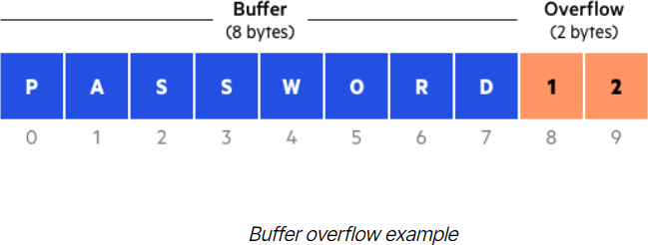

Buffer Overflow Attack

Attackers exploit buffer overflow issues by overwriting the memory of an application. This changes the execution path of the program, triggering a response that damages files or exposes private information. For example, an attacker may introduce extra code, sending new instructions to the application to gain access to IT systems.

If attackers know the memory layout of a program, they can intentionally feed input that the buffer cannot store, and overwrite areas that hold executable code, replacing it with their own code. For example, an attacker can overwrite a pointer (an object that points to another area in memory) and point it to an exploit payload, to gain control over the program.

Types of Buffer Overflow Attacks

- Stack-based buffer overflows are more common, and leverage stack memory that only exists during the execution time of a function.
- Heap-based attacks are harder to carry out and involve flooding the memory space allocated for a program beyond memory used for current runtime operations.

What is system hacking? Explain Linux and Windows Hacking.

System Hacking
System hacking is a vast subject that consists of hacking the different software- based technological systems such as laptops, desktops, etc. System hacking is defined as the compromise of computer systems and software to access the target computer and steal or misuse their sensitive information. Here the malicious hacker exploits the weaknesses in a computer system or network to gain unauthorized access to its data or take illegal advantage.

Linux Hacking
As we all know, Linux is an Operating System (OS) assembled user the model of open-source software development and distribution and is based on Unix OS created by Linus Torvalds.
Now to hack a Linux-based computer system and get access to a password protected Linux system, we have to know Linux's basic file structure. As we know,
Linux is considered to be the most secure OS to be hacked or cracked, but in the world of Hacking, nothing is 100% secured.
Hackers usually use the following techniques to hack the Windows system.

- Hack Linux using the SHADOW file.
- Another technique commonly used by hackers is to bypass the user password option in Linux.
- In another technique, the hacker detects the bug on Linux distribution and tries to take advantage of it.

Windows Hacking
The user password of Windows OS, which appears after the Windows starts logging in, lets users protect the computer from getting unauthorized access. Choosing a strong password of more than eight digits is an excellent practice. Henceforth you can protect your files and folders from the hands of malicious users. There are several tricks and techniques to crack a windows password. But, from the hacker's point of view, if you can use social engineer your victim and find a Windows computer open, you can easily modify the existing password and give a new password that will be unaware of the victim or the owner of the computer.

What can the attackers do after compromising the system?

  - Ruin the victim's data by deleting the files.
  - Steal files and folders.
  - Hijack victim's username and password.
  - Steal money and credit card details while the victim is doing e-marketing or online transaction.
  - Sell victim's information to third parties who may use this information for illicit purposes.
  - Create traffic to shut down your website.
  - Get access to the servers and manipulate the files, programs, etc.

What is Eavesdropping and Explain any two Eavesdropping methods.
Eavesdropping
An eavesdropping attack occurs when a hacker intercepts, deletes, or modifies data that is transmitted between two devices. Eavesdropping, also known as sniffing or snooping, relies on unsecured network communications to access data in transit between devices.

Eavesdropping Methods are:

Pickup Device

Attackers can use devices that pick-up sound or images, such as microphones and video cameras, and convert them into an electrical format to eavesdrop on targets. Ideally, it will be an electrical device that uses power sources in the target room, which eliminates the need for the attacker to access the room to recharge the device or replace its batteries.

Some listening devices are capable of storing digital information and transmitting it to a listening post. Attackers may also use mini amplifiers that enable them to remove background noise.

Transmission Link

A transmission link between a pickup device and the attacker’s receiver can be tapped for eavesdropping purposes. This can be done in the form of a radiofrequency transmission or a wire, which includes active or unused telephone lines, electrical wires, or ungrounded electrical conduits. Some transmitters can operate continuously, but a more sophisticated approach involves remote activation.

Listening Post

A listening post is used to transmit conversations intercepted by bugs on telephones. When a telephone is picked up to make or take a call, it triggers a recorder that is automatically turned off when the call is ended.
Listening posts are secure areas in which signals can be monitored, recorded, or retransmitted by the attacker for processing purposes. It can be located anywhere from the next room to the telephone up to a few blocks away. The listening post will have voice-activated equipment available to eavesdrop on and record any activity.

Weak Passwords

Weak passwords make it easier for attackers to gain unauthorized access to user accounts, which gives them a route into corporate systems and networks. This includes hackers being able to compromise confidential communication channels, intercept activity and conversations between colleagues, and steal sensitive or valuable business data.

Open Networks

Users who connect to open networks that do not require passwords and do not use encryption to transmit data provide an ideal situation for attackers to eavesdrop.
Hackers can monitor user activity and snoop on communications that take place on the network.

Explain DoS, DDoS and PoD attacks.

DOS and DDOS
A DoS attack tries to make a web resource unavailable to its users by flooding the target URL with more requests than the server can handle. That means that during the attack period, regular traffic on the website will be either slowed down or completely interrupted.

A Distributed Denial of Service (DDoS) attack is a DoS attack that comes from more than one source at the same time. A DDoS attack is typically generated using thousands (potentially hundreds of thousands) of unsuspecting zombie machines. The machines used in such attacks are collectively known as “botnets” and will have previously been infected with malicious software, so they can be remotely controlled by the attacker. According to research, tens of millions of computers are likely to be infected with botnet programs worldwide.

Ping of Death
Ping of Death (a.k.a. PoD) is a type of Denial of Service (DoS) attack in which an attacker attempts to crash, destabilize, or freeze the targeted computer or service by sending malformed or oversized packets using a simple ping command.

While PoD attacks exploit legacy weaknesses, which may have been patched in target systems. However, in an unpatched system, the attack is still relevant and dangerous. Recently, a new type of PoD attack has become popular. This attack, commonly known as a Ping flood, the targeted system is hit with ICMP packets sent rapidly via ping without waiting for replies

Unit 5
- Explain about the following wireless terminology:
- Access Point
- Hotspot
- GSM
- SSID

Access point (AP) or Wireless Access Point (WAP):An AP is used to connect wireless devices to connect to a wireless/wired network. It is a hardware device that allows wireless connectivity to the end devices. The access point can either be integrated with a router or a separate device connected to the router.

Hotspot:These are places where wireless networks are available for public use. Hotspots refer to ares with Wi-Fi availability, where users can enable Wi-Fi on their devices and connect to the internet

Global System for Mobile Communication (GSM):It is a standard by European Telecommunication Standards Institute. It is a second generation (2G) protocol for digital cellular networks. 2G was developed to replace 1G (analog) technology. This technology has been replaced by 3G UMTS standard, followed by 4G LTE standard. Mostly GSM networks operate in 900MHz or 1800MHz frequency bands.

Service Set Identifier (SSID):It is a unique identifier od a WLAN that is 32 alphanumeric characters in length. SSID is a token used to identify and locate 802.11(Wi-Fi) networks.

3 Explain the concept of Shared Key authentication process.

Shared Key authentication Process:
Shared Key authentication mode requires four frames to complete the process of authentication.
- The first frame is the initial authentication request frame that sent by the client to the responder or access point.
- Access point responds the authentication request frame with the authentication response frame with the challenge text.
- The client will encrypt the challenge with the shared secret key and send it back to the responder.
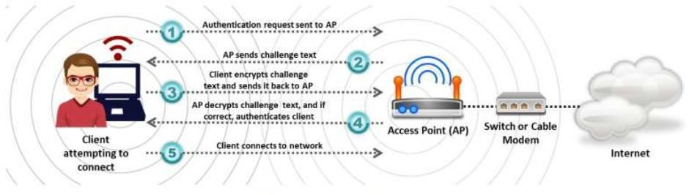
- Responder decrypts the challenge with the shared secret key. If the decrypted challenge matches with the challenge text, successful authentication response frame is sent to the client.

4 What is War driving?

War driving comes from an old term called war dialling, where people would dial random phone numbers in search of modems. War driving is basically people driving around looking for vulnerable APs to attack. People will even use drones to try and hack APs on higher floors of a building. A company that owns multiple floors around ten stories up might assume nobody is even in range to hack their wireless, but there is no end to the creativity of hackers!
5 Explain bluejacking attack?
Bluejackingis the use of Bluetooth to send messages to users without the recipient's consent, similar to email spamming. Prior to any Bluetooth communication, the device initiating the connection must provide a name that is displayed on the recipient's screen. As this name is user-defined, it can be set to be an annoying message or advertisement. Strictly speaking, Bluejacking does not cause any damage to the receiving device. However, it may be irritating and disruptive to the victims.
Bluejacking attackthe attacker can sniff, jam, and take control of the data transmission between BLE devices by performing an MITM attack. Following a successful attempt, the attacker can also bypass security mechanisms and listen to the information being shared. To implement this attack, the attacker must use affordable firmware-embedded equipment and minor software coding.

6 Explain about WEP Encryption and steps to break WEP Encryption.

WEP Encryption:
Wired Equivalent Privacy (WEP) is an oldest and weakestencryption protocol. It was developed to ensure the security of wireless protocols however it is highly vulnerable. It uses 24-bit initialization vector (IV) to create a stream cipher RC4 with Cyclic Redundant Check (CRC) to ensure confidentiality and integrity. Standard 64- bit WEP uses the 40-bit key, 128- bit WEP uses 104-bit key and 256-bit WEP uses a 232-bit key. Authentications used with WEP are Open System authentication and Shared Key authentication.

Working of WEP Encryption:
Initialization Vector (IV) and Key together is called WEP Seed. This WEP Seed is used to from RC4 Key. RC4 generates a pseudorandom stream of bits. This pseudorandom stream is XORed with the Plain text to encrypt the data. CRC-32 Checksum is used to calculate the Integrity Check Value (ICV).

Weak Initialization Vector (IV) :
The one of the major issues with WEP is with Initialization Vector (IV) . IV value is too small to protect from reuse and replay. RC4 Algorithm uses IV and Key to create a stream using Key Scheduling algorithm. Weak IV reveal information. Collection of weak IV will be the base key. WEP has no built-in provision to update key.

Breaking WEP Encryption:
Breaking WEP encryption can be performed by following the steps mentioned below: -

- Monitor the Access point channel.
- Test Injection Capability to the Access point.
- Use tool for Fake Authentication.
- Sniff the packets using Wi-Fi Sniffing tools
- Use Encryption tool to inject Encrypted packets
- Use the Cracking tool to extract the encryption key from IV.

- Discuss some defence against Bluetooth hacking

Defence Against Bluetooth Hacking:
- use non-regular pattern as PINs while pairing a device. Key combinations should not be sequential on the keypad.
- Keep Bluetooth in the non-discoverable (hidden) mode.
- Do not accept any unknown or unexpected request for pairing.
- Regularly check of all devices paired in the past and delete any suspicious paired device.
- Always enable encryption when establishing a Bluetooth connection.
- Set the network range of a Bluetooth-enabled device to the lowest and perform pairing only in a secure area.
- Install antivirus software that supports host-based security software on Bluetooth-enabled devices.

- Explain about two different types of Bluetooth modes

Bluetooth modes:
A user can set Bluetooth in the following modes.
  - Discoverable mode
  - Limited discoverable mode

  - When Bluetooth devices are in the discoverable mode, they are visible to other Bluetooth-enabled devices. If a device attempts to connect to another, the
device attempting to establish the connection must search for a device that is in the discoverable mode; otherwise, the device attempting to initiate the connection will not be able to detect the other device. The discoverable mode is necessary only while connecting to a device for the first time. Upon saving the connection, the devices remember each other; therefore, the discoverable mode is not necessary for lateral connection establishment.
- : In the limited discoverable mode, the Bluetooth devices are discoverable only for a limited period, for a specific event, or during temporary conditions. However, there is no Host Controller interface (HCI) command to set a device directly in the limited discoverable mode. A user has to do this indirectly When a device is set to the limited discoverable mode, it filters out non-matched IACs and reveals itself only to those that matched.

10 marks
Unit 1:

- What is Ethical Hacking and explain different Phases of Ethical Hacking.
Ethical hacking involves an authorized attempt to gain unauthorized access to a computer system, application, or data. Carrying out an ethical hack involves duplicating strategies and actions of malicious attackers. This practice helps to identify security vulnerabilities which can then be resolved before a malicious attacker has the opportunity to exploit them.

Phases Involved in Ethical Hacking:
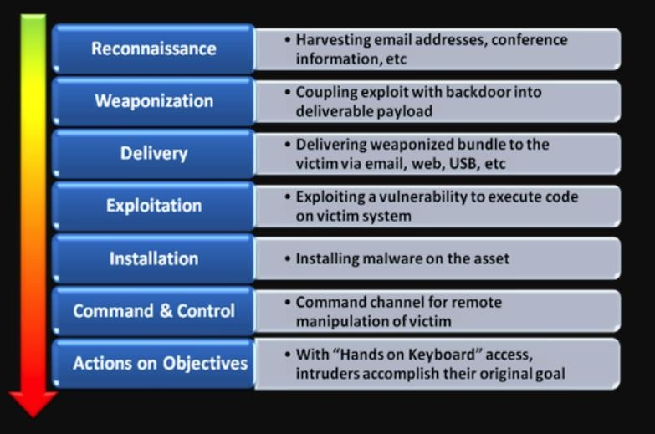

Reconnaissance

    - Generally,known as Information Gathering
    - It is s a set of processes and techniques (Footprinting, Scanning & Enumeration) used to covertly discover and collect information about a target system
•

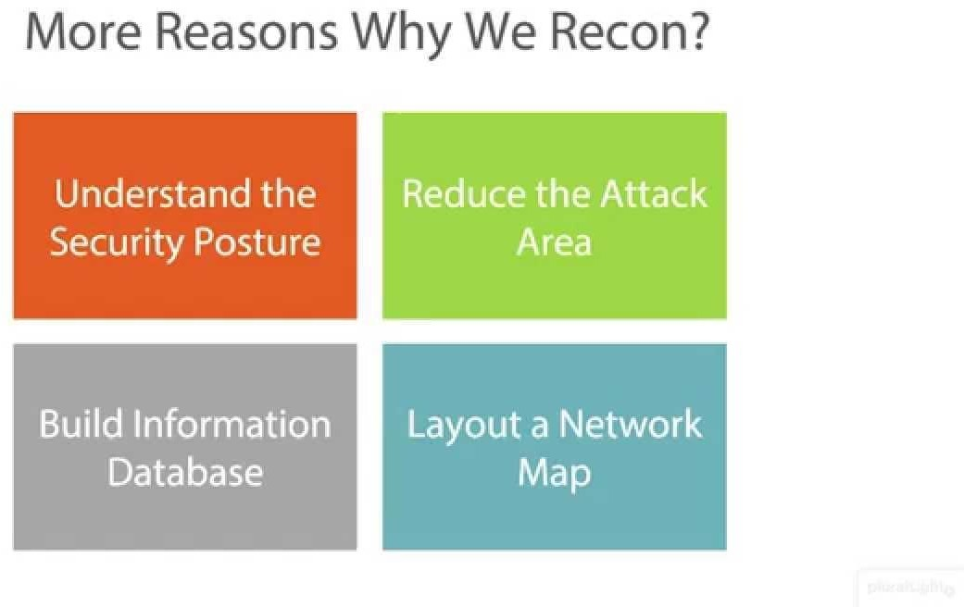

    - Some Information includes-

- Domain Name
- IP Address
- Employee Information
- Phone Number
- Email Address

Weaponization

    - This step happens at the attacker side
    - Coupling exploit with backdoor into deliverable payload
    - Here attackers have finished their research into your organization’s vulnerabilities and have selected their targets. In this step, they are working out how best to get inside the network. This might be through a virus or malware tailored to exploit known vulnerabilities

Delivery

    - The three most prevalent delivery vectors for weaponized payloads by attackers were observed to be email attachments, websites, and removable media such as a USB stick
    - This step involves transmitting the weapon to the target

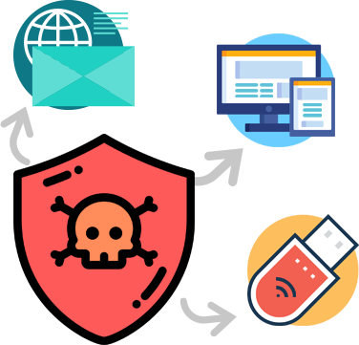

Exploitation

    - In this step, the malware starts the action. The program code of the malware is triggered to exploit the target’s vulnerability/vulnerabilities
    - Often, exploitation targets an application or operating system vulnerability, but it could also more simply exploit the users themselves or leverage an operating system feature that auto-executes code

Installation

    - Once the exploitation of the system has been successful, the malware code will install itself onto the targeted information system
    - Here malware also installs an access point for the intruder / attacker. This access point is also known as the backdoor

Command & Control

    - In this phase the attacker puts in place their management and communication code onto to the target network
    - This software allows the attacker to fully manage the code in the environment and allows the attacker to move deeper into the network, exfiltrate data and conduct destruction or denial of service operations

Actions on Objectives
    - Once the attacker / intruder gains persistent access, they finally take action to fulfill their purpose, such as encryption for ransom, data exfiltration or even data destruction

4.Who is a hacker and describe different categories of Hackers.

Hackers are well aware of the working within the computer and networking in organizations. The intention behind the hacking determines the type of hacker they are. Getting unauthorized access to systems or networks is illegal and termed as hacking. So, one might wonder what hackers do on getting access to the system, well they can use vulnerable points in the system to bring the system down or steal confidential data. There are different kinds of hackers
  - White Hat Hackers
  - Black Hat Hackers
  - Gray Hat Hackers
  - Script Kiddies
  - Green Hat Hackers
  - Blue Hat Hackers
  - Red Hat Hackers
  - State/Nation Sponsored Hackers
  - Hacktivist
  - Malicious insider or Whistleblower

White Hat Hackers
White hat hackers are computer professionals with expertise in cybersecurity. They are authorized or certified to hack the systems. These White Hat Hackers work for governments or organizations by getting into the system. They hack the system from the loopholes in the cybersecurity of the organization. This hacking is done to test the level of cybersecurity in their organization. By doing so, they identify the weak points and fix them to avoid attacks from external sources. White hat hackers work as per the rules and regulations set by the government. They are also known as ethical hackers.

Black Hat Hackers
Black hat hackers are also knowledgeable computer experts but with the wrong intention. They attack other systems to get access to systems where they do not have authorized entry. On gaining entry they might steal the data or destroy the system. The hacking practices used depends on the hacking individual’s capacity and knowledge. As the intentions of the hacker make the hacker a criminal. The malicious action intent of the individual cannot be gauged either can the extent of the breach while hacking.

Gray Hat Hackers
The intention behind the hacking is considered while categorizing the hacker. The Gray hat hacker falls in between the black and white hat hackers. They are not certified, hackers. The hackers work with either good or bad intentions. The hacking might be for their gain. The intention behind hacking decides the type of hacker. If the intention is for personal gain then the hacker is considered to be a gray hat hacker.

Script Kiddies
It is a known fact that half knowledge is always dangerous. The Script Kiddies are amateurs in the field of hacking. They try to hack the system with scripts from other fellow hackers. They try to hack the systems, networks, or websites. The intention behind the hacking is just to get attention from their peers. Script Kiddies are juveniles who do not have complete knowledge of the hacking process.

Green Hat Hackers
Green hat hackers are learning the ropes of hacking. They are slightly different from the Script Kiddies due to their intention. The intent is to strive and learn to become full-fledged hackers. They are looking for opportunities to learn from experienced hackers.

Blue Hat Hackers
Blue Hat Hackers are similar to Script Kiddies. The intent to learn is missing. They use hacking as a weapon to gain popularity among their fellow beings. They use hacking to settle scores with their adversaries. Blue Hat Hackers are dangerous due to the intent behind the hacking rather than their knowledge.

Red Hat Hackers
Red Hat Hackers are synonymous with Eagle-Eyed Hackers. They are similar to white hackers. The red hat hackers intend to stop the attack of black hat hackers. The difference between red hat hackers and white hat hackers is in the process of hacking through intention remains the same.
Red hat hackers are quite ruthless while dealing with black hat hackers or counteracting with malware. The red hat hackers continue to attack and may end up having to replace the entire system set up.

Above are 7 types of hackers broadly referred to in the cyber security world. The three types of hackers listed below work in a different capacity.

State/Nation Sponsored Hackers
Government appoints hackers to gain information about other countries. These hackers are known as State/Nation sponsored hackers. They use their knowledge to gain confidential information from other countries to be well prepared for any upcoming danger to their country. The sensitive information aids to be on top of every situation but also to avoid upcoming danger. They report only to their governments.

Hacktivist
The hackers intend to hack government websites. They pose themselves as activists, so known as a hacktivist. Hacktivist can be an individual or a bunch of nameless hackers whose intent is to gain access to government websites and networks. The data gained from government files accessed are used for personal political or social gain.

Malicious insider or Whistleblower
An individual working in an organization can expose confidential information. The intent behind the exposure might be a personal grudge with the organization or the individual might have come across the illegal activities within the organization. The reason for expose defines the intent behind the exposure. These individuals are known as whistleblowers.

Unit 2:

3.What is network scanning and explain different types of Scanning

Network scanning is one of the components of intelligence gathering and information retrieving mechanism an attacker used to create an overview scenario of the target organization
Types of Scanning

- Connect scan
- Half-Open-Scan / Stealth scan
- XMAS scan
- FIN scan
- ACK scan
- Null scan
- Idle scan
- Port Scanning
- Network Scanning
- Vulnerability Scanning
XMAS scan: This is a l so called as inverse TCP scanning. This works by sending packets set with PSH,URG,FIN flags. The targets do not respond if the ports are open and send are set response if ports are closed.

Connect scan: Identifies open ports by establishing a TCP handshake with the target.
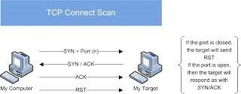

Nmapcommand:nmap-sT -v-p-<TargetIP>

Half-open scan otherwise known as Stealth scan used to scan the target in a stealthy way by not completing the TCP handshake by abruptly resetting the communication.

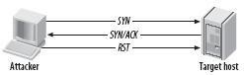

Nmapcommand:nmap-sS -v<TargetIp>

FIN scan: F in flag is set in the TCP packets sent to the target. Open ports do not respond while closed ports send are set response.
ACK scan: Here the attacker sets the ACK flag in the TCP header and the target's port status is gathered based on window size and TTL value of RESET packets received from the target.
Null Scan: Works by sending TCP packets with no flags set to the target. Open ports do not respond while closed ports respond with a RESET packet.
Idle Scan: Here the attacker tries to mask his identity uses an idle machine on the network to probe the status detail softer get ports.
Port Scanning: In this process the hacker identifies available and open ports and understands what services are running. You must understand the ports and port numbers. The ports number scan be in these three ranges:
  - Well known Ports from 0 to 1023
  - Registered ports from 1024 to 49151
  - Dynamic Ports from 49152 to 65535

Banner Grabbing: Is a process of collecting information like operating system details, the name of the service running with its version number etc.

Network Scanning: This means to look for active machines or targets on the network. This can be done using tools or scripts that ping to all IP addresses on the networks and get a list of the alive nodes and their IP addresses.

Vulnerability Scanning: This is the mechanism where the target is scanned or looked for any vulnerability. In this scan the Operating system is found out with installed patches etc. and then based on the information vulnerabilities are found in that particular version of Operating System.

Explain TCP Communication Flags.

TCP flags are used within TCP packet transfers to indicate a particular connection state or provide additional information. Therefore, they can be used for troubleshooting purposes or to control how a particular connection is handled. There are a few TCP flags that are much more commonly used than others as such SYN, ACK, and FIN. However, in this post, we're going to go through the full list of TCP flags and outline what each one is used for.

List of TCP flags

Each TCP flag corresponds to 1 bit in size. The list below describes each flag in greater detail. Additionally, check out the corresponding RFC section attributed to certain flags for a more comprehensive explanation.

- SYN - The synchronization flag is used as a first step in establishing a three-way handshake between two hosts. Only the first packet from both the sender and receiver should have this flag set. The following diagram illustrates a three-way handshake process.

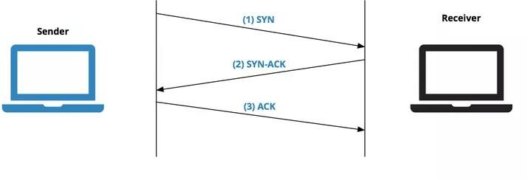

- ACK - The acknowledgment flag is used to acknowledge the successful receipt of a packet. As we can see from the diagram above, the receiver sends an ACK as well as a SYN in the second step of the three-way handshake process to tell the sender that it received its initial packet.
- FIN - The finished flag means there is no more data from the sender. Therefore, it is used in the last packet sent from the sender.
- URG - The urgent flag is used to notify the receiver to process the urgent packets before processing all other packets. The receiver will be notified when all known urgent data has been received.
- PSH - The push flag is somewhat similar to the URG flag and tells the receiver to process these packets as they are received instead of buffering them.
- RST - The reset flag gets sent from the receiver to the sender when a packet is sent to a particular host that was not expecting it.
- ECE - This flag is responsible for indicating if the TCP peer is ECN capable.
- CWR - The congestion window reduced flag is used by the sending host to indicate it received a packet with the ECE flag set. NS (experimental) - The nonce sum flag is still an experimental flag used to help protect against accidental malicious concealment of packets from the sender.

Unit 3:

Explain phases of Vulnerability Assessment life cycle?
Vulnerability Assessment life cycle includes the following phases:

Creating Baseline
Creating Baseline is a pre-assessment phase of the vulnerability assessment life-cycle in which pentester or network administrator who is performing assessment identifies the nature of the corporate network, the applications, and services. He creates an inventory of all resources and assets which helps to manage, prioritize the assessment. furthermore, he also maps the infrastructure, learns about the security controls, policies, and standards followed by the organization. In the end, baseline helps to plan the process effectively, schedule the tasks, and manage them with respect to priority.

Vulnerability Assessment
Vulnerability Assessment phase is focused on assessment of the target. The assessment process includes examination and inspection of security measures such as physical security as well as security policies and controls. In this phase, the target is evaluated for misconfigurations, default configurations,faults, and other vulnerabilities either by probing each component individually or using assessment tools. Once scanning is complete, findings are ranked in terms of their priorities. At the end of this phase, vulnerability assessment report shows all detected vulnerabilities, their scope, and priorities.
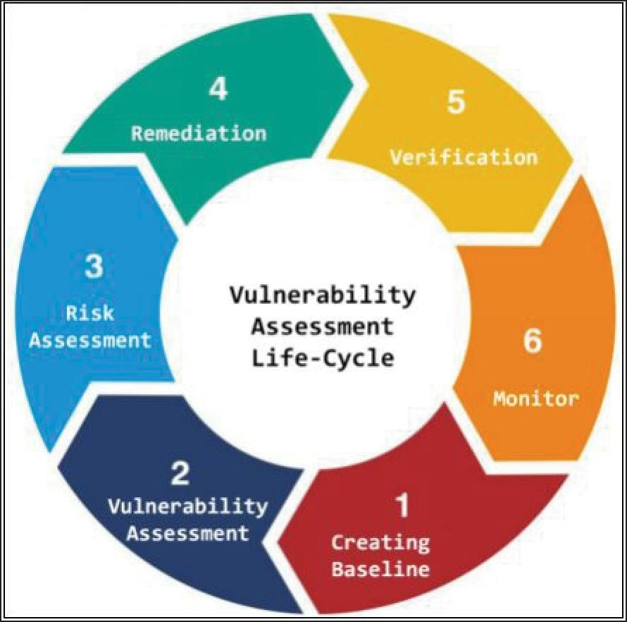
Figure 2. Vulnerability Assessment Lifecycle

Risk Assessment

Risk Assessment includes scoping these identified vulnerabilities and their impact on the corporate network or on an organization.

Remediation
Remediation phase includes remedial actions for these detected vulnerabilities. High priority vulnerabilities are addressed first because they can cause a huge impact.

Verification
Verification phase ensures that all vulnerabilities in an environment are eliminated.

Monitor

Monitoring phase includes monitoring the network traffic and system behaviors for any further intrusion

Unit 4:

What is password cracking and Explain any 3 Malware Attack types.
Password Cracking
Password cracking refers to various measures used to discover computer passwords. This is usually accomplished by recovering passwords from data stored in, or transported from, a computer system. Password cracking is done by either repeatedly guessing the password, usually through a computer algorithm in which the computer tries numerous combinations until the password is successfully discovered.

- Password cracking can be done for several reasons, but the most malicious reason is in order to gain unauthorized access to a computer without the
computer owner’s awareness. This results in cybercrime such as stealing passwords for the purpose of accessing banking information.

- Other, nonmalicious, reasons for password cracking occur when someone has misplaced or forgotten a password. Another example of nonmalicious password cracking may take place if a system administrator is conducting tests on password strength as a form of security so that hackers cannot easily access protected systems.

Malware Attacks Types
- Virus
We tend to refer to all malware as viruses, but it’s not so. A virus modifies other legitimate host files in such a way that when you execute a file in the victim’s system, you also execute the virus. Today, with different kinds of malware infecting the cyber world, computer viruses have become rather uncommon; they comprise less than 10% of all malware.
Remember, viruses infect other files, they are the only malware that infect other files and hence it’s really hard to clean them up. Even the best among antivirus programs struggle with this; most of the time they either delete or quarantine the infected file and don’t get rid of the virus itself.
- Worm
A worm is self-replicating and spreads without end-user action, causing real devastation. Viruses need end users to kick them off so that they can go on and infect other files and systems. On the other hand, worms don’t need any such end- user action. They’d simply spread by themselves, self-replicating in the process and destroying systems, devices, networks and connected infrastructure as well.
Worms spread by exploiting other files and programs to do the spreading work. When one person in an organization opens an email that contains a worm, the entire network in the organization could get infected in just a few minutes.
- Trojan
Trojans, reminding you of what happened during the Trojan war, masquerade as legitimate programs. However, they contain malicious instructions. Trojans mostly arrive via email or spread from infected websites that users visit. They only work when the victim executes it. A user may find a pop up that tells him his system was infected. The pop up would instruct him to run a program to clean his system. He takes the bait, without knowing that it is a Trojan. Trojans are very common, especially because it is easy to write Trojans. Additionally, they are easy because Trojans spread by tricking end-users to execute them. This effectively renders security software useless.
- Ransomware
Ransomware, as the name suggests, demands a ransom from you to get things back on track. The main issue with ransomware, which would spread tremendously fast across organizations, networks, and countries, is that they encrypt all files in a system or network, rendering them inaccessible. A ransom note pops up, demanding payment in cryptocurrency, for decrypting the files . If the ransom is not paid, the encrypted files could eventually get destroyed and hence ransomware should be seen as one of the most devastating forms of malware. Most ransomware are Trojans and spread through social engineering. Unfortunately, in some cases, hackers refuse to decry-pt files even after you pay the ransom.
- Adware
Adware is nothing but attempting to expose users to unwanted, potentially
malicious advertising. These ads most likely end up infecting a user’s device. There are adware programs that redirect a user, during browser searches, to look- alike web pages that have promotions of other products. Removing adware is easier. You just need to find the malicious executable and remove it.
- Spyware
Spyware, as the name suggests, helps hackers spy on systems and their users. This kind of malware can be used for key-logging and similar activities, thereby helping hackers gain access to personal data (including login credentials) and intellectual property. Spyware is also used by people who want to keep a check on the computer activities of people personally known to them. Spyware, like adware, is easy to remove.

Unit 5

- Explain the different types of wireless network.
There are different types of wireless networks:

Extension to a Wired Network:
A user can extend a wired network by placing Aps between a wired network and wireless devices. A wireless network can also be created using AP. In this type of network, the AP acts as a switch, providing connectivity for computers that use a wireless NIC. The AP can connect wireless clients to a wired LAN, which allows wireless access to LAN resources such as file servers and internet connections.
The types of APs Include:

- Software APs (SAPs):SAPs can be connected to a wired network, and they run on a computer equipped with a wireless network interface card (NIC).

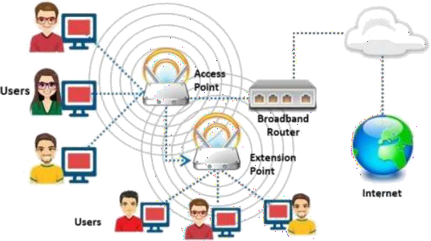
- Hardware APs (HAPs): HAPs supports most wireless features

In this type of network, the AP acts as a switch, providing connectivity for computers that use a wireless NIC. The AP can connect wireless clients to a wired LAN, which allows wireless access to LAN resources such as file servers and internet connections.
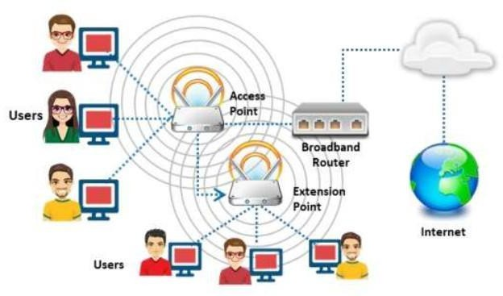

Multiple Access Point:
This type of network connects computers wirelessly using multiple APs. If a single AP cannot cover an area, multiple APs or extension points can be established.
The wireless area of each AP must overlap its neighbour’s area. This provides users
the ability to move around seamlessly using a feature called roaming. Some

Wmanufactures develop extensionpoints that act as wireless relays, extending the range of a single AP. Multiple extension.

LAN-to-LAN Wireless Network:

Aps provide wireless connectivity to local computers, and local computers on different networks can be interconnected. All hardware Aps have the capability to interconnect with other hardware Aps.
However, interconnecting LANs over wireless connections is a complex task
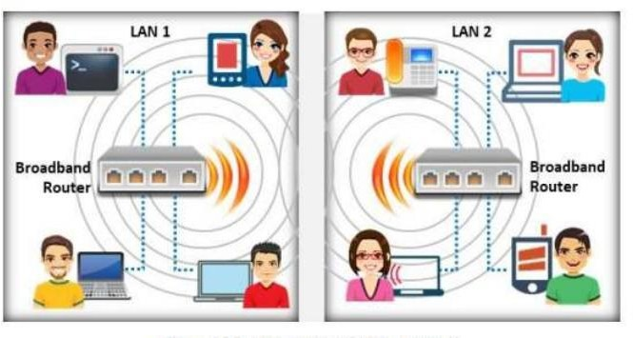

3G/4G Hotspot:

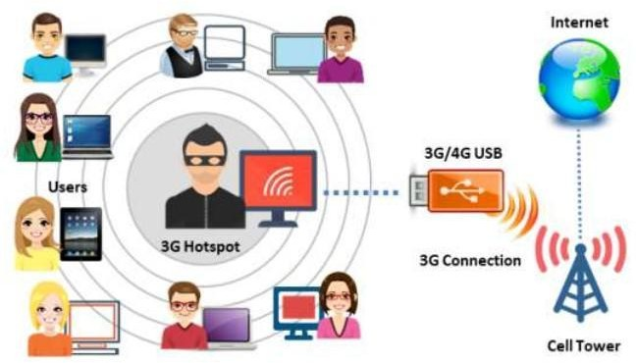
A 3G/4G hotspot is type of wireless network that provides Wi-Fi access to Wi-fi enabled devices, including MP3 players, notebooks, tablets, cameras, PDAs, netbooks, and more

